Claddach Kirkibost Centre
Isle of North Uist
HS6 5EP

E: nudc@isleofnorthuist.com
W: www.isleofnorthuist.com
Company No. SC383175
Charity No. SC 041709

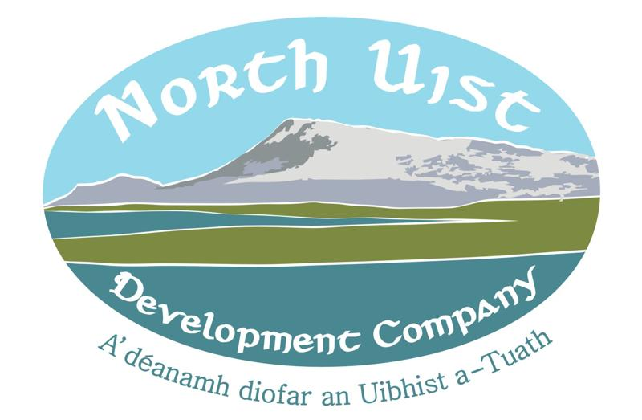

Project Manager - ‘Àrainneachd Àlainn’ Community Hub and Environment Centre

Job Description

Title Project Manager – ‘Àrainneachd Àlainn’ Lochmaddy Community Hub and Environment Centre
Reporting to Project Delivery Manager / Board of Directors
Employer North Uist Development Company
Salary £29,782.32 pro rata for 3 months and capped expenses at £200
Term of contract 3 months. Possibility of extension should further funding be acquired.
Location Negotiable; remote working with associated online meetings; however, must be willing to travel to Lochmaddy, Isle of North Uist for on-site project management.
Working hours 35 hours per week
Leave entitlement Pro-rata of 30 days (inclusive of bank holidays).

The Project

The North Uist Development Company (NUDC) was founded in March 2010 with its core aim to develop a sustainable and viable community through promoting social, educational, cultural, economic and environmental wellbeing in North Uist. NUDC meets this core aim through development projects. The North Uist Community Development Plan guides NUDC’s project delivery, and the Lochmaddy Community Hub and Environment Centre is a key project and focus for The Company.

Gathering together the views of the local community through numerous consultations, the proposed development in Lochmaddy will provide a community hub filling the needs of the local community to improve health and wellbeing, provide improved facilities and services, support business growth for economic development, and provide long-term work opportunities to help sustain the population. There are also the wider needs of helping to maintain young people on the island, reducing the population decline; as well as the need of conserving the local environment for the benefit of all present and future generations. The proposed community business will meet these needs by:
- Providing local employment opportunities by creating a self-sustaining community business
- Increasing the local economy by providing a visitor attraction, helping to sustain increased visitors by providing low cost accommodation, providing tourist information to engage and direct onwards to other businesses and facilities, and helping to drive local innovation through training in the learning environment.
- Providing a community hub as a local focal point and meeting place with community-based facilities and services, with the community environment fully embedded throughout the development.
- Providing space to nurture therapeutic and learning activities for community benefit
- Providing an incubator hub to nurture innovation and encourage young enterprise to support a younger generation and helping sustain the fragile population.
- Providing an Environment Centre to act as an engagement point to aid conservation of the local environment, an education point for the local community and visitors to the islands.
- Providing cross generational and younger based activities in all aspects of the development.

It is important to maintain a flexible development to change with the needs of the community. This is why the final designs incorporate a flexible multi-purpose space to adapt to community needs. This currently includes: space for a learning environment for educational activities, space for co-working for those working remotely online as an ‘incubator hub’, offices for NUDC and others including business start-ups, rentable space for creative or therapeutic services and, and a dedicated area for community use, with all areas for the local community as well as visitors.

Funding has been acquired for particular aspects of the development for Phase 1 and Phase 2. The Project Manager will deliver the next steps in the project which includes; but is not limited to; the construction of the Environment Centre, and to establish the sustainable business model.

Tasks and Responsibilities Include:

- Project manage the next steps of the project, involving all aspects of the Centre with associated contractors;
- Review funding applications and agreements to set the project plan and, manage the project plan, with responsibility for flagging dependencies and risks;
- Project manage tender and procurement processes;
- Ensure project deliverables with funders are achieved, on budget and on time;
- Generate a financially sustainable business model to meet the needs of the community, including early stage generation of income;
- Generate a marketing and communications plan;
- Create a community based sub-committee including young islanders and local businesses;
- Support the production of any associated project reports for stakeholders - including funders;
- Support and manage collaborations with external organisations;
- Community and Stakeholder communication, including via social media;
- Convene and support effective management of regular project design and management meetings with stakeholders, including building standards and planning.

Key Deliverables

- Develop a project management plan for activities, deliverables and risks and update monitoring plan.
- Project Management of Asset transfer completion of the former Lochmaddy School.
- Project Management of the Environment Centre in the former sports hall, working with tendered contractors.
- Project Management of the external toilet block, working with the planning authority and contractors.
- Establish a community based sub-committee and complete further community consultation in liaison with the architect.
- Ensure the building is fit for purpose, liaising with building standards and, establish a business model with defined marketing plan to cover operational costs.
- Meet funders requirements as per funding applications and agreements, including associated reporting.

Funds available are time limited, with funds to be spent by April 2021 and, this will need to be managed efficiently by working closely with funders and contractors.

The Candidate

We are seeking an experienced project manager with:
- A proven and successful track record of delivering complex projects;
- Excellent organisation skills and the ability to use resources and people to meet deadlines;
- Strong communication and inter-personal skills to deliver the next stage of this project;
- A passion and commitment to working in liaison with associated stakeholders, contractors and funders; for inclusive community focussed project delivery;
- Flexible and quick to adapt to a new project and work setting;
- Available to start immediately;
- Desirable: experience in similar community based island projects;
- Desirable: ability to communicate in Scottish Gaelic.

Applicants should submit their CV and a covering letter by the closing date of the 25th of January 2021 at noon. Telephone queries about the position to Ameena Camps on 07729832686.

